Experiment 12. Sensitivity to temperature

(a) Collect three jars or beakers of about the same size. Fill one with cold water (10-15 °C), one with hot water (40-50 °C) and the third with warm water (about 25 °C).

(b) Place the first finger of the left hand in the cold water and the first finger of the right hand in the hot water. Leave both fingers immersed for at least one minute.

(c) After one minute, remove both fingers from the jars and dip them repeatedly but a1ternately in the warm water for about a second at a time (Fig. 1). Notice the temperature sensation in each
finger.
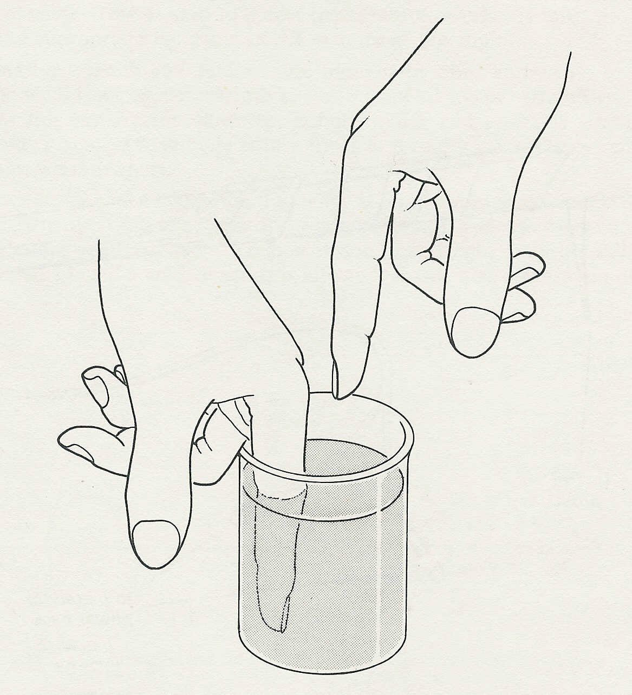

warm water

Fig. 1

Experiment 12 Discussion

1 What impression did (i) the left finger, (ii) the right finger give about the temperature of the
warm water?

2 Why should there be any difference in the sensory information from the two fingers? How could you modify the experiment to test your suggestion?

3 Does the result mean that the skin of your fingers is incapable of judging whether an object is hot or cold?

4 What does the result suggest about the way in which the skin responds to temperature?

