Experiment 12. The effect of indoleacetic acid on coleoptiles

You are provided with two dishes containing moist cotton wool on which wheat or oat seedlings are growing.

(a) Copy the table on p. 12.02 into your notebook.

(b) Use forceps to remove from the cotton wool any grains which have
(i) failed to produce a coleoptile of 10 mm or more,
(ii) been tipped over by the growth of the root system,
(iii) developed distorted or excessively long coleoptiles (over 40 mm),
(iv) the first leaf emerging through the coleoptile.
In this way, reduce the number of seedlings in each dish to 10 even if it means removing healthy
specimens.

(c) Label the dishes A and B with a spirit marker and add your initials to each.

(d) Measure the length of each coleoptile in millimetres (Fig. 1) by holding the cotton wool in one hand and letting it drape over the second finger so that the coleoptile can be held against a ruler. Alternatively, use a pair of dividers. There is no need to identify individual seedlings since average lengths only are to be compared. Record the lengths in your table.

(e) Pick up a little lanolin on the end of a splint or match-stick and apply a blob of lanolin to the tip of each coleoptile in dish A. To do this, pick up the cotton wool and hold it as described
in (d) so that the coleoptiles can be gripped between the thumb and first finger while applying the lanolin.

(f) Repeat the operation with seedlings from dish B but use a fresh splint and apply lanolin
containing 1 % indole acetic acid (IAA). Try to place the lanolin on the tip of the coleoptile
and not on the sides.

(g) Moisten the cotton wool, place both dishes in the box provided and leave for 1-7 days
(2 days is best).

(h) After 1-7 days take the cotton wool from each dish in turn, cut off the coleoptiles and measure them again, recording the lengths in your table. If the first leaf has emerged, do not measure this but only the coleoptile (Fig. 2).

(i) Total the coleoptile lengths in each column and calculate the average length. Calculate the increase in length by subtracting the first average length from the final average length.
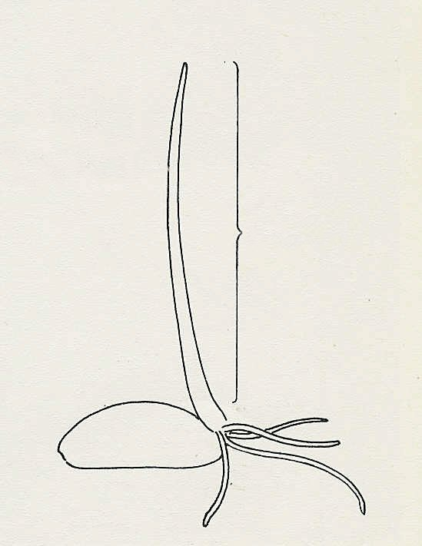
coleoptile
measure
Fig. 1

