Experiment 12. Conducting pathways in the shoot

(a) Fill the large container with water.

(b) Withdraw the syringe plunger to the top mark or beyond and fit the syringe to the cut end of the stem by means of the rubber tubing.

(c) Immerse the leafy shoot in the container of water and press the syringe plunger (Fig. 2). Keep the pressure as high as possible without breaking the seal between the rubber tubing and the syringe.

(d) Maintain the pressure for about 30 seconds and look for any signs of bubbles appearing from the stem or leaves.

(e) Cut all or most of the leaves transversely across in the mid-line
(Fig. 1) to leave only the lower half of the leaf attached to the
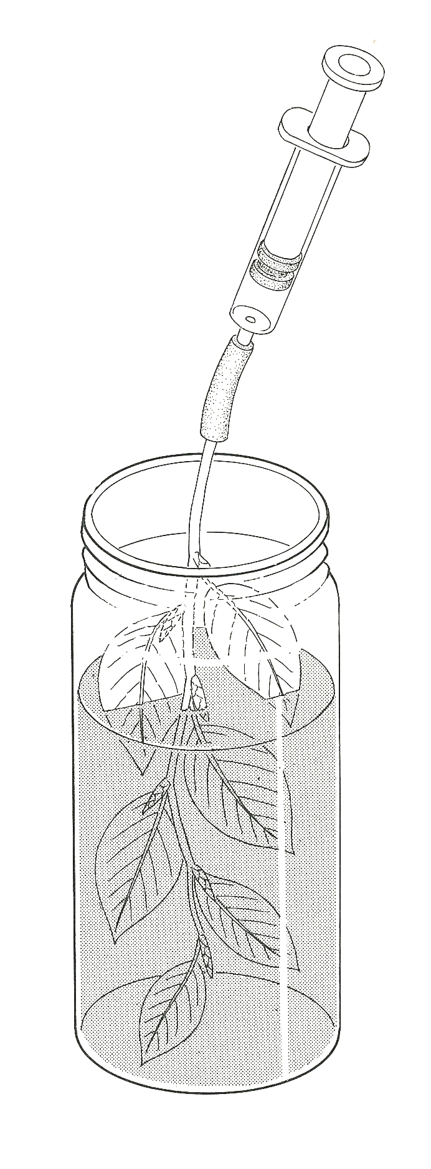
stem. Repeat the experiment, maintaining the pressure for at least
30 seconds.

(f) Now cut the leaves off completely, leaving only the petioles
(leaf stalks) attached to the stem and repeat the experiment.

(g) Finally, cut a piece of stem about 5 cm long. Fill the syringe
air
with water, connect it to the twig, point the apparatus vertically
upwards and very slowly depress the plunger to see if it is
possible to force water through the stem (Fig. 3).

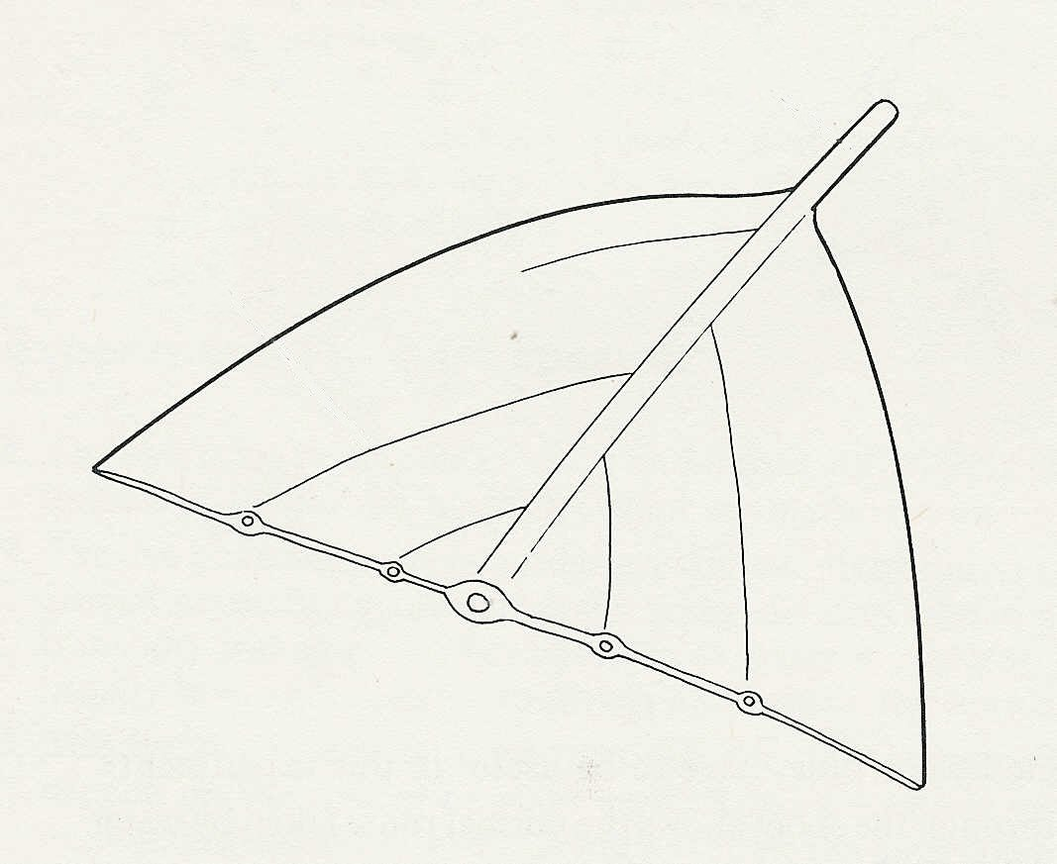
Fig. 2
Fig. 1
petiole
vein

