Experiment 11 Recognition of separate stimuli

Outline A specially prepared 'hair-pin' is used to apply single or double stimuli to the skin. In some areas the double stimulus cannot be recognized unless the points are widely separated.

Prior knowledge Some general ideas about the presence of sensory nerve endings in the skin; the generation and transmission of nerve impulses to the brain in sensory nerve fibres.

Advance preparation and materials

'Hair-pin'. Cut 16 cm lengths of 20 swg (0.9mm) copper wire and bend them to the shape shown in Fig. 1. When closed, the lower probe should be about 1 mm shorter than the upper. This enables a single stimulus to be given even when the points are very close
together. Round off the ends of the wire on a sharpening stone or file. Compasses, dividers, pins and other sharp objects are not recommended for this experiment.
lt is comparatively easy for the experimenter to hold the points of the 'hair-pin' a fixed distance
apart during each series of 20 tests.

A ruler with markings in mm.

Recording the results. A great deal of time can be saved by providing the students with
duplicated sheets carrying blank tables as on p. 11.01.

NOTE. The system of testing and method of scoring are designed to make the tests as objective as possible, but students may find the instructions difficult to follow at first. It helps if the teacher gives a demonstration to begin with.
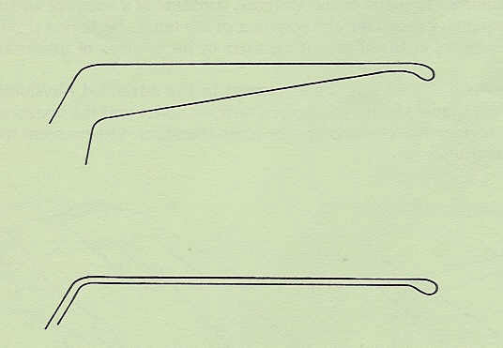
Fig. 1

