Experiment 11 Discussion - answers

1 Finger-tips will probably recognize the two points even when they are only about 2 mm apart,
i.e. the lower limit of this instrument. The back of the hand will probably need a separation of l0 mm to achieve a score of 8-10. Other areas will probably be even less sensitive. One authority states that on the skin of the back, the points must be 65 mm apart to recognize the double stimulus with any confidence.

2 Possibilities:
(a) One point does not touch a receptor (Fig. 2a). It seems unlikely that, on the back of the
hand, a pressure actually indenting the skin will not affect at least one receptor. Moreover,
recognition of two stimuli when they are separated by half a second suggests that it is not
shortage of receptors alone which causes poor discrimination.

(b) Both points touch receptors which feed impulses into one nerve fibre (Fig. 2b). Since a
single sensory fibre may receive branches from sensory endings covering a region of several
square millimetres this explanation is quite plausible. The recognition of the non-simultaneous
double stimulus could be explained by the additional burst of impulses initiated by a second,
stimulus (Fig. 2c). It has been claimed that single hair follicle receptors are sensitive over an
area several centimetres in diameter but the 65 mm separation claimed for the back could
hardly be explained in this way.

(c) There are two receptors and two sensory fibres but unless the impulses are separated in
time, they cannot be discriminated by the brain. This does not explain why some regions
discriminate better than others and merely transfers the mystery to another part of the body.
However, since the various sensory systems are associated with greater or lesser areas of
cortex, it may be that the analytic capabilities of the cortex are more limited for some receptors
than others.

(d) Lateral inhibition. In many visual systems, stimulus of a receptor adjacent to another, also
being stimulated, cancels out the response of the latter. Perhaps a similar system applies to
the tactile sensors of the skin, with greater or lesser areas of inhibition.

NOTE. There seems to be no general agreement in the advanced physiology books about the
reasons for different spatial sensitivity. Several authors assert that the distance between the points is the smallest in regions where receptors are most abundant. Others seem to doubt that this is a satisfactory explanation.
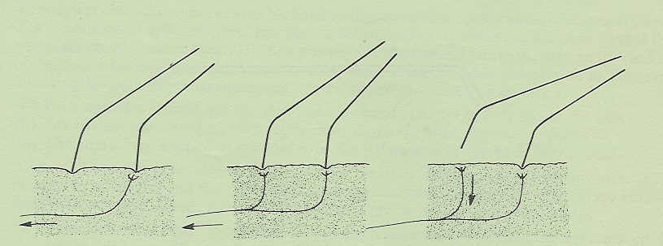
(a) Only one receptor affected
(b) Both receptors feed impulses into the same fibre
(c) Only one fibre but stimuli separated in time
Fig 2

