(g) Test the front of the wrist and finger-tips in the same way, treating all four finger-tips as the test area.

(h) Retest the area of least sensitivity as follows:
(i) Set the points to the distance which gave a low score.
(ii) Follow one of the plans of stimulation previously used but this time, when two stimuli are
to be given, separate the stimuli in time by about half a second, i.e. do not apply both
points simultaneously as before. Make a note of any difference this method of stimulation has
on the successful recognition of a double stimulus.

Experiment 11 Discussion

1 For each region tested, what were the minimum distances between the points which could still
be recognized as separate stimuli?

2 Suggest reasons for the different spatial sensitivity of the regions as shown by your tests. The
explanations should consider the distribution and density of touch receptors and their possible connections to nerves.
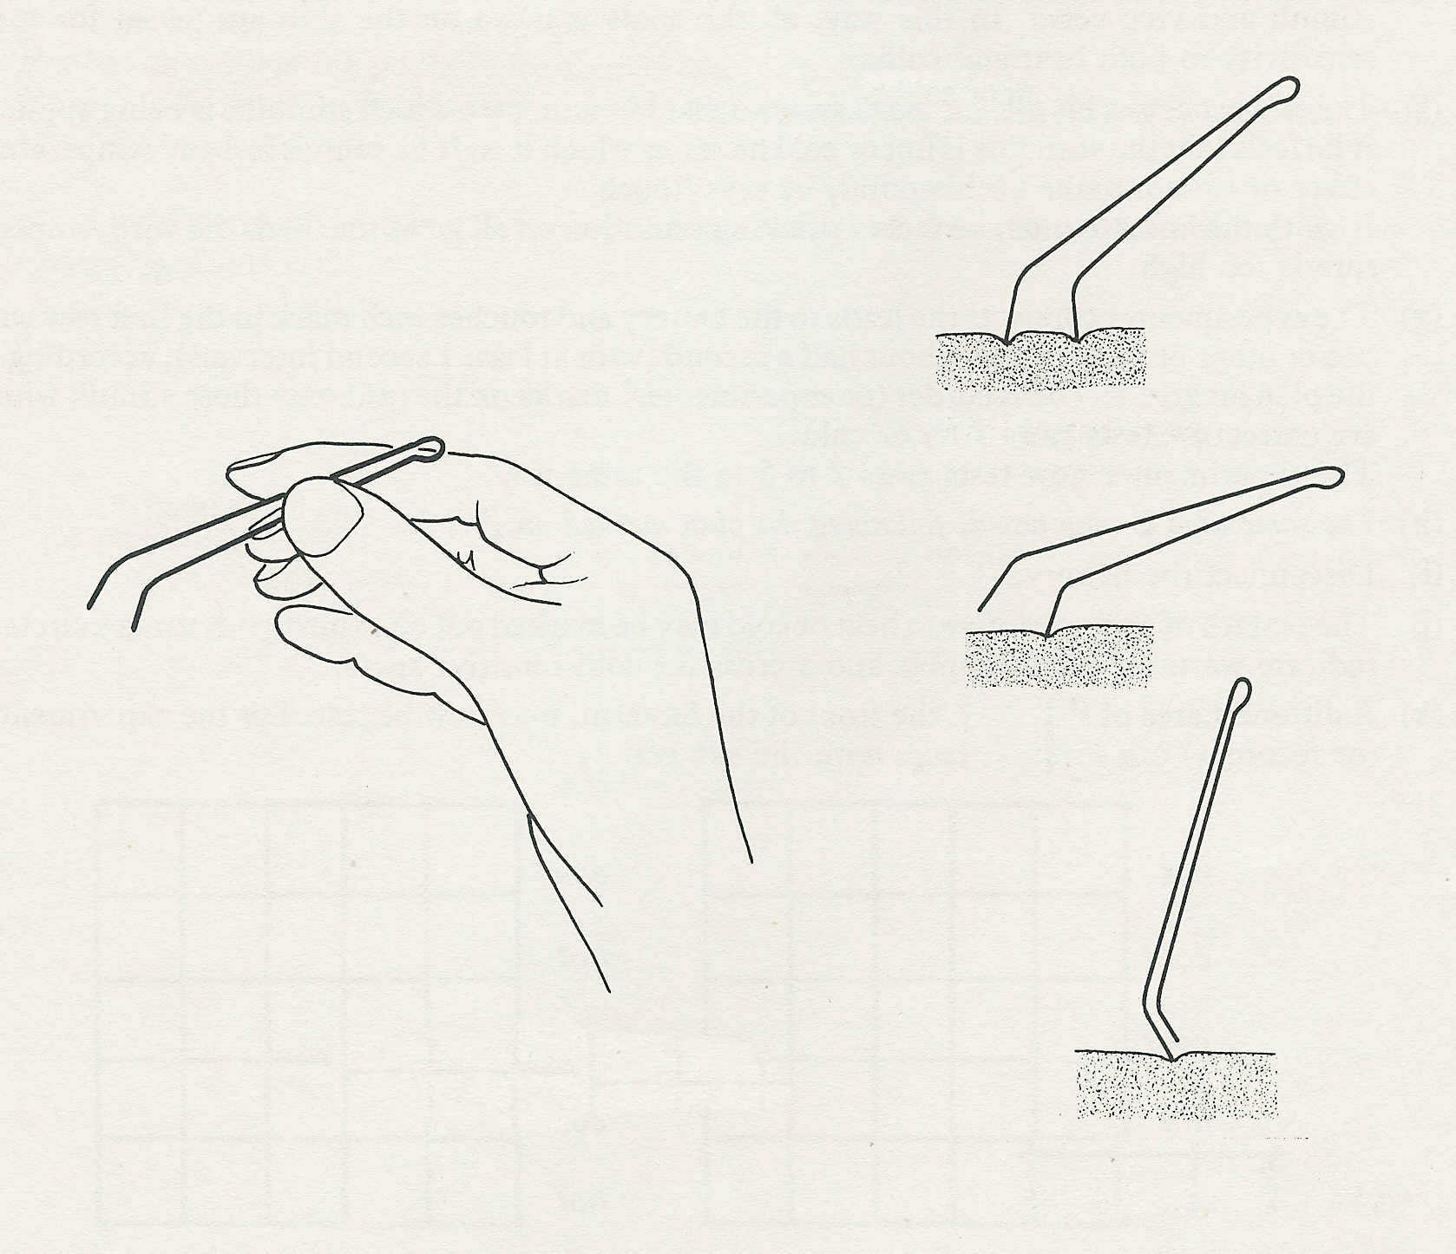
Fig. 2
Fig. 1
Double stimulus
Single stimulus
Grip the wires to keep the
points a fixed distance apart
Single stimulus;
points close together

