Experiment 11. To trace the path of water through the shoot

CARE. Methylene blue will stain your clothes. Wear a laboratory coat if possible and take care not to drop or flick the dye.

(a) Place a freshly cut shoot in a small quantity of methylene blue solution and leave it for 30
minutes in bright light.

(b) At intervals of about 10 minutes, without removing the shoot from the dye, study the stem and leaves to see if there is any evidence of movement of the dye. Note which leaves, if any, have the dye in their veins.

(c) After 30 minutes, or longer if necessary, examine the shoot again and note any changes in the distribution of the dye.

(d) Fill a beaker or jar with cold water for rinsing the dye off the stem.

(e) Remove the shoot from the methylene blue and carefully wash the dye from the stem, in the jar of water. With a razor blade or scalpel cut across the stem a few millimetres from the bottom (Fig. 1), avoiding the region which has become deeply stained with the dye. Examine the cut
surface of the stem with a hand lens and make a simple outline diagram to show the distribution of dye in the stem.

(f) Select a leaf whose veins have been coloured by the dye. Use a razor blade to cut across the stalk and the leaf blade and examine the cut surfaces with your lens. Make drawings in your
notebook to show the distribution of the dye in the leaf stalk and leaf blade.

(g) If the shoot is not needed for further experiments, the stem can be cut across at higher and
higher levels to see how far the dye has travelled.
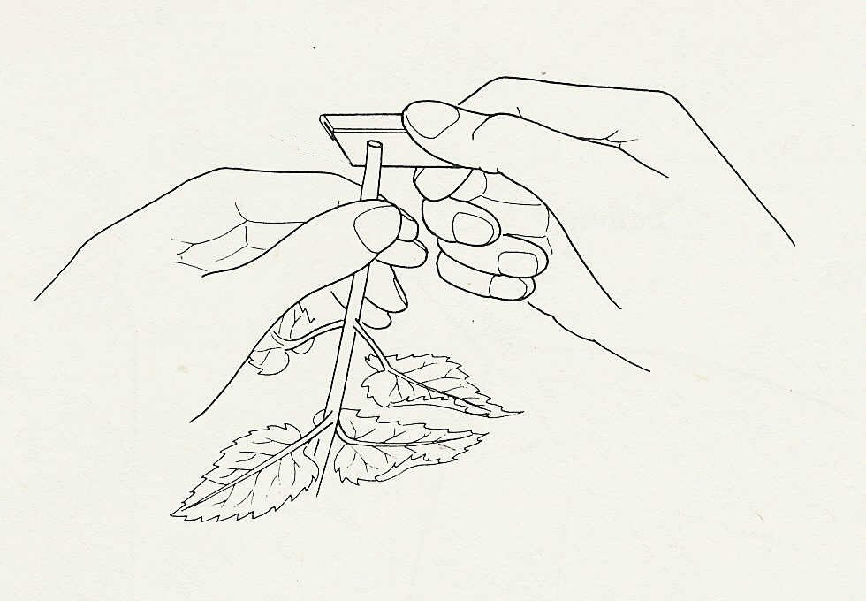

cut across the stem

Fig. 1

Experiment 11 Discussion

1 What properties must a dye, such as methylene blue, have to be useful in this experiment?

2 It is assumed that the movement of dye through the shoot shows the normal route taken by water through a plant. What objections are there to this assumption?

3 Assuming that these objections can be dismissed, describe the path taken by water through the stem to the leaf as revealed by your experiment.

