Experiment 11. The region of detection and response to one-sided lighting in coleoptiles

(a) Copy the table given below into your notebook.

(b) Use forceps to remove any seedlings which are falling over, or with coleoptiles which are distorted, or less than about 10 mm, or more than about 50 mm.

(c) (i) Use fine scissors to cut 5 mm from the coleoptile tips of one third of the seedlings.
(ii) Use forceps to place aluminium foil caps over the tips of one third of the seedlings.
(iii) Leave the remainder intact (Fig. 3).

(d) Measure the length of the coleoptiles in millimetres and record these figures in your table.
It is not necessary to identify individual seedlings since only the totals will be compared.

(e) Use a spirit marker to write your initials on a Petri dish base and also mark a vertical line-on the edge. Place the cotton wool and seedlings in the dish and moisten the cotton wool.

(f) Arrange the dish 15-30 cm from a bench lamp so that the mark on the dish is towards the lamp and the bulb is level with the edge of the dish (Figs.1 and 2).

(g) Screen the experiment from direct light from other sources.

(h) After 3, 5 and 24 hours examine the seedlings and make drawings of a representative coleoptile from each group. After 24 hours, measure the coleoptiles and record the lengths in your table. If the first leaf has emerged, DO NOT include this in your measurement of the coleoptile. Calculate the total increase in length for each group of seedlings.

 | Terminal 5mm cut off |  |  | Terminal 5 mm covered |  |  | Intact seedlings
 | first length | second length | change in direction | first length | second length | change in direction | first length | second length | change in direction
Total
Increase

intact
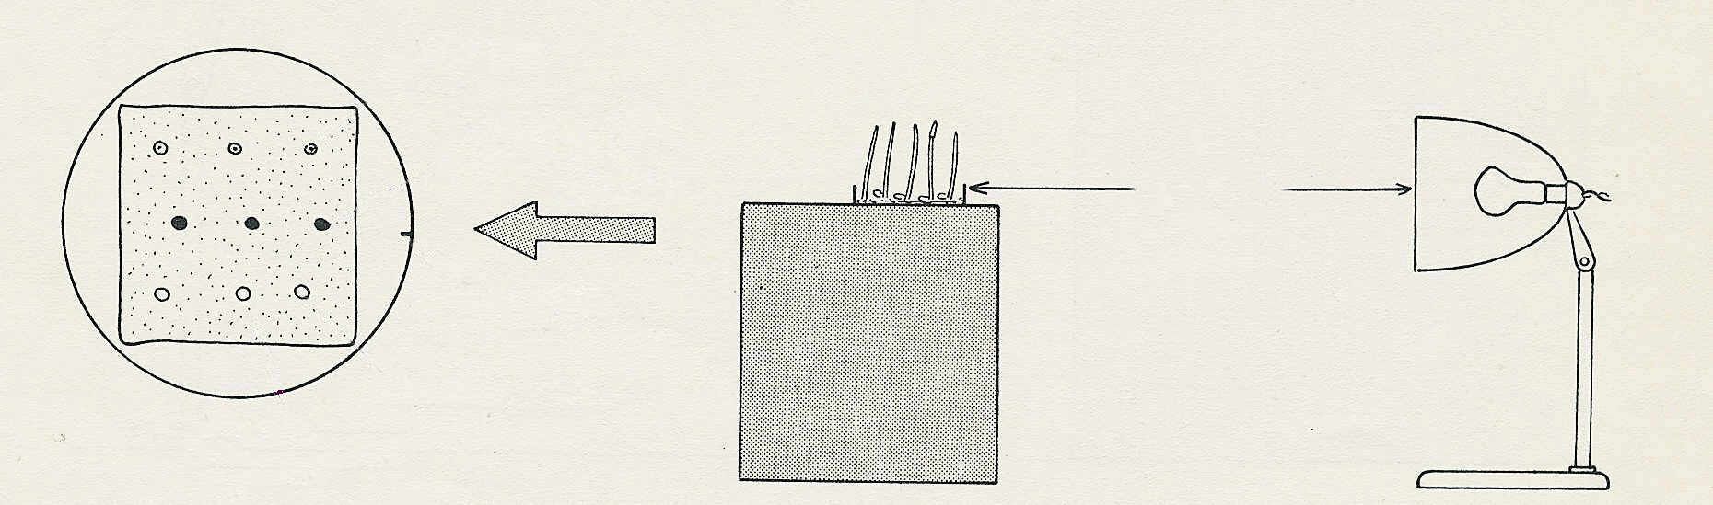
tips covered
mark
decapitated
moist
cotton wool
LIGHT
15-30 cm
Fig. 1
Fig. 2

