Experiment 10 Sensitivity to touch - preparation

Advance preparation and materials

Rubber stamp. (i) A No.3 rubber finger-cone from the stationers will cut up to give four 1 cm squares with 25 projections. Glue the squares to a short wooden rod (Fig. 1a).
(ii) Alternatively, with a ball-point pen, mark a 3 mm grid on an eraser and cut a shallow groove along each marked line with a tenon saw. Then cut the eraser into 15 mm square blocks each with 25 projections (Fig. 1b).

Pin-holder. Cut strips of. fine-grained wood about 100 mm x 5 mm x 10 mm. Thin dowel rod or beading strip will do. About 10mm from one end, drill a hole 1 mm in diameter and
pass a red-hot wire through to smooth off the sides (Fig. 2).

Pins. Pins with spherical plastic heads are suitable (from stationers or haberdashers). They
weigh between 0.1 and 0.2 g. Heat the points to redness in a Bunsen flame, allow to cool
slowly and cut off the points with pliers. Smooth the ends on a file or sharpening stone to give a circular cross-section.
To store the pins it is advisable to drill holes in a block of wood to hold the entire stock. Check
that the pins move smoothly in the holders with the minimum of friction.

Recording charts. A great deal of class time can be saved by preparing duplicated sheets with
20 or 30 of the grids shown on p. 10.01 for the students in recording their results.

Ink pads. One ink pad can be shared between several groups.
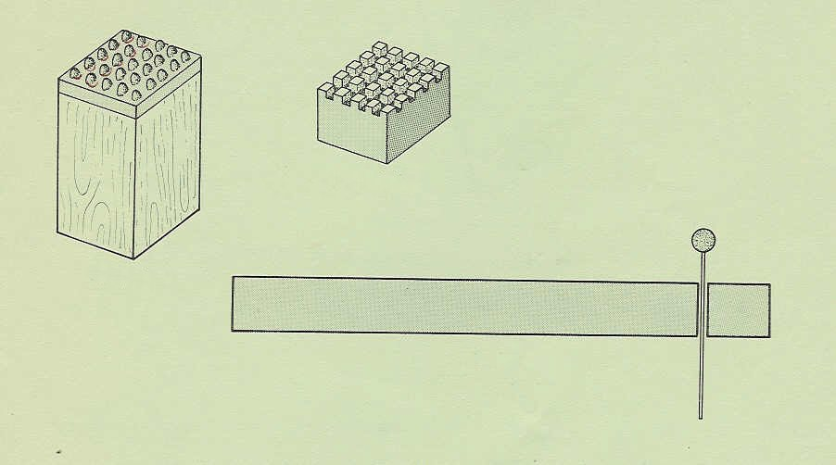
Fig. 1a
Fig. 1b
Fig. 2

