Experiment 10. To collect and identify the product of transpiration

(a) You are provided with a potted plant. Water the soil if it appears to be dry.

(b) Place a transparent plastic bag over the entire shoot and close the mouth of the bag firmly round the base of the stem with a wire tie or something similar (Fig. 1).

(c) Place the plant under an artificial light-source or in a position where it can receive sunlight.

(d) After several hours in the light, note any changes of conditions inside the plastic bag.

(e) Remove the plastic bag carefully, hold it with the open end upward and shake the collected
liquid into one corner.

Remove a sample of the liquid with a clean dropping pipette and test it by dropping it on to
some anhydrous copper sulphate or blue cobalt chloride paper.

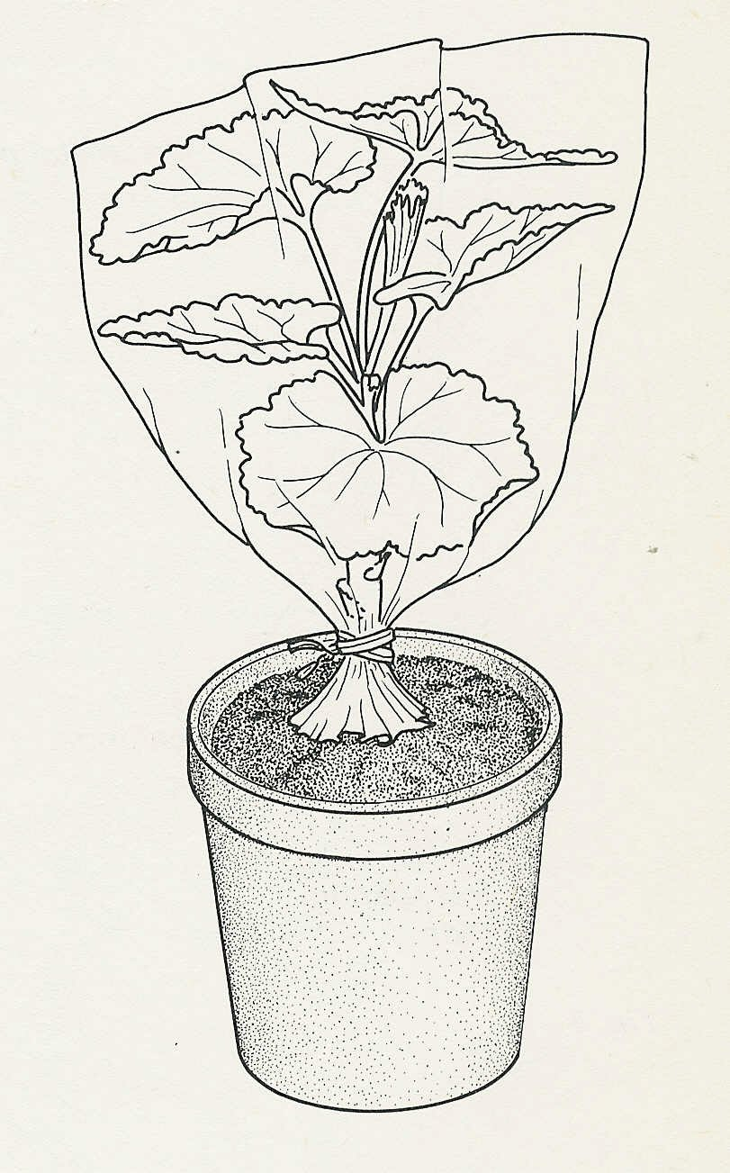
Experiment 10. Discussion

1 Describe the changes that had taken place in the plastic bag.

2 Where could the liquid have come from?

3 What controls would have to be carried out to be
reasonably sure about the source of this liquid?

4 What evidence is there that the liquid (a) contains
water, (b) is pure water?

5 What tests would have to be carried out to verify that the liquid was pure water?

Fig. 1

