Experiment 1. Discussion

1 Was there a significant difference in reaction times using sight and touch (a) for your own
results, (b) for the class results when averaged?

2 The nervous pathway for the motor impulses from brain to forearm was probably the same for
both experiments but the sensory pathway from eye to brain was much shorter than from
finger-tips to brain. What differences in results would this lead you to expect?

3 State whether you think the class results fulfilled this expectation. If they did not, discuss
possible reasons for their not doing so.

4 Assuming, for the moment that, in the touch experiment, the time of reaction is the same as the time taken for the nerve impulse to travel from the sensory organs in the finger-tips to the brain and back to the forearm, calculate the speed of conduction, in cm per second, of the nerve
impulse by dividing the distance travelled by the reaction time.

5 The conduction velocity of nerve impulses in, mammalian nerve fibres ranges from 2 to 100 m per second. Your results are probably about 5 to 15 m per second. What are the faults in the assumption made in question 4 that might account for this low value?

6 Although it was the fingers which gripped the ruler, you were told to measure the distance to the forearm. Why was this?

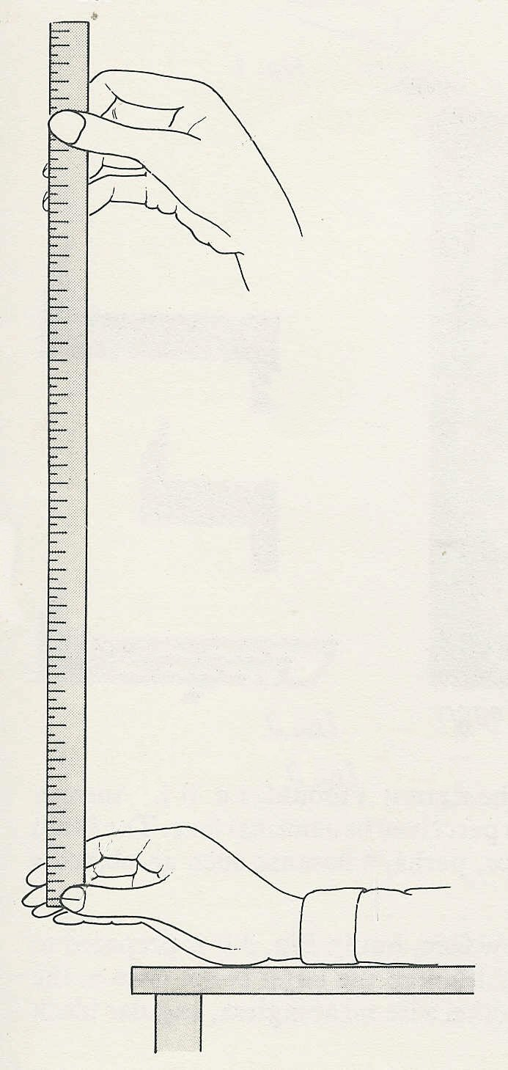
experimenter

Fig. 1

mark on thumb

subject’s forearm rests on bench

distance in cm | time in seconds |  | distance in cm | time in seconds
1 | 0.045 |  | 21 | 0.207
2 | 0.064 |  | 22 | 0.212
3 | 0.078 |  | 23 | 0.217
4 | 0.090 |  | 24 | 0.221
5 | 0.102 |  | 25 | 0.226
6 | 0.111 |  | 26 | 0.230
7 | 0.120 |  | 27 | 0.235
8 | 0.128 |  | 28 | 0.239
9 | 0.136 |  | 29 | 0.243
10 | 0.143 |  | 30 | 0.247
11 | 0.150 |  | 31 | 0.252
12 | 0.156 |  | 32 | 0.256
13 | 0.163 |  | 33 | 0.260
14 | 0.169 |  | 34 | 0.263
15 | 0.175 |  | 35 | 0.267
16 | 0.181 |  | 36 | 0.271
17 | 0.186 |  | 37 | 0.275
18 | 0.192 |  | 38 | 0.278
19 | 0.197 |  | 39 | 0.282
20 | 0.202 |  | 40 | 0.286
Table 3

