Experiment 1. The action of amylase on starch

(a) Prepare a water bath by using a Bunsen burner to heat some water in a beaker on a
tripod and gauze till it boils; then turn down the flame to keep the water just boiling.
While waiting for the water to boil carry on from (b ).

(b) Label four test-tubes 1-4.

(c) Using a syringe or graduated pipette, place 5cm³ 2% starch solution in each tube.

(d) Rinse the syringe or pipette and use it to place 2cm³ amylase solution in each of tubes 2 and 3 and shake the tubes to mix the contents. Leave the tubes for 5 minutes and copy the table below into your notebook.

(e) After 5 minutes, add 3 drops of iodine solution to tubes 1 and 2.

(f) Rinse the syringe or graduated pipette and use it to add 3 cm³ Benedict's solution to tubes 3 and 4 and place both tubes in the water bath for 5 minutes.

(g) Compare the final colours in the tubes and complete the table of results.

Tube | Contents | Tested with | Result | Interpretation
1 | 2% starch solution | iodine
2 | 2% starch solution + amylase | iodine
3 | 2% starch solution + amylase | Benedict’s
4 | 2% starch solution | Benedict’s

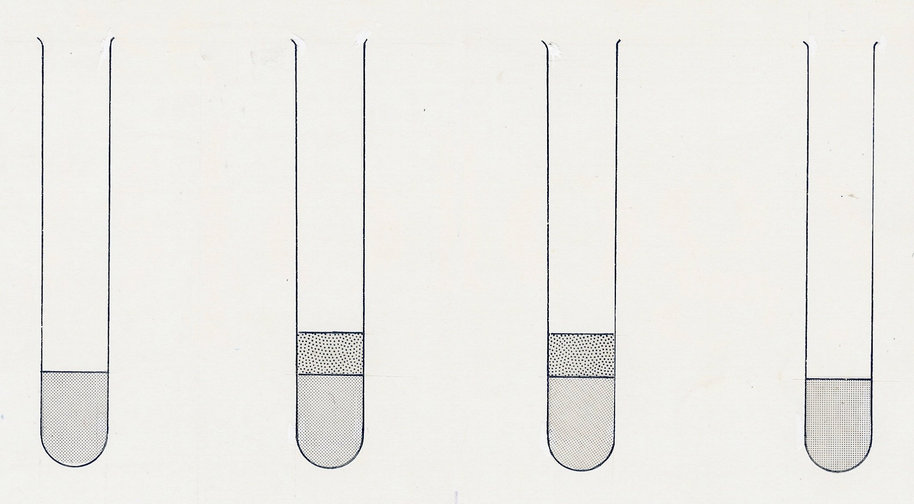
1
2
3
4
2% starch
2 cm³
amylase

AFTER 5 MINS – add 3 drops of iodine solution AFTER 5 MINS – test with Benedict’s solution

