Experiment 1. Osmosis

(a) Use a dropping pipette to fill the cellophane tube and connector with syrup solution
(Fig. I).

(b) Push the capillary tube into the connector far enough to bring the syrup to a level somewhere in the lower third of the capillary (Fig. 2).

(c) If there are short columns of liquid and air bubbles trapped in the upper part of the capillary, squeeze the cellophane tubing to force the syrup to the top of the capillary and then let it return slowly.

(d) Clamp the capillary tube vertically in a stand and then lower it to immerse the cellophane tubing in a beaker or jar of water until it is completely covered but not touching the bottom of the vessel (Fig. 3). Leave for a minute so that the syrup can acquire the temperature of the water .

(e) Move the rubber band on the capillary to mark the level of the liquid.

(f) Watch the level of the liquid in the capillary. If it falls rapidly, examine the cellophane tube through the side of the beaker to see if syrup is escaping.
Measure any change in level after 10 minutes.
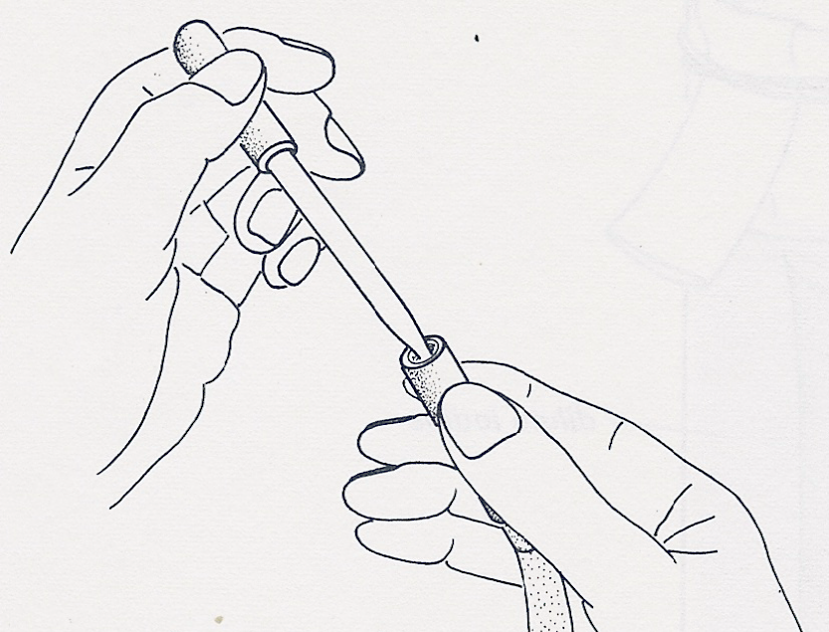
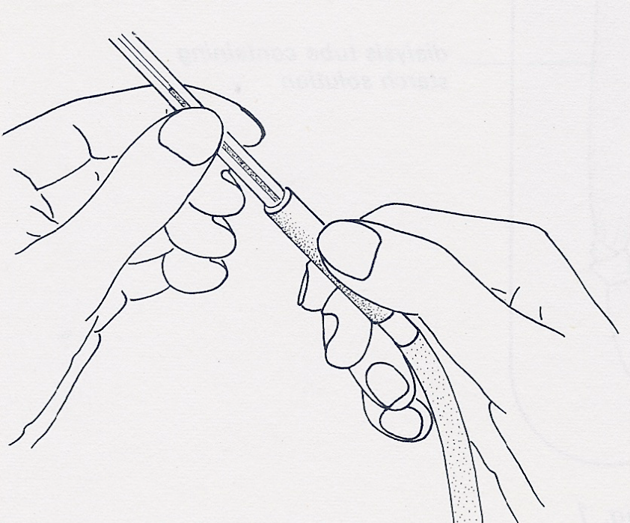

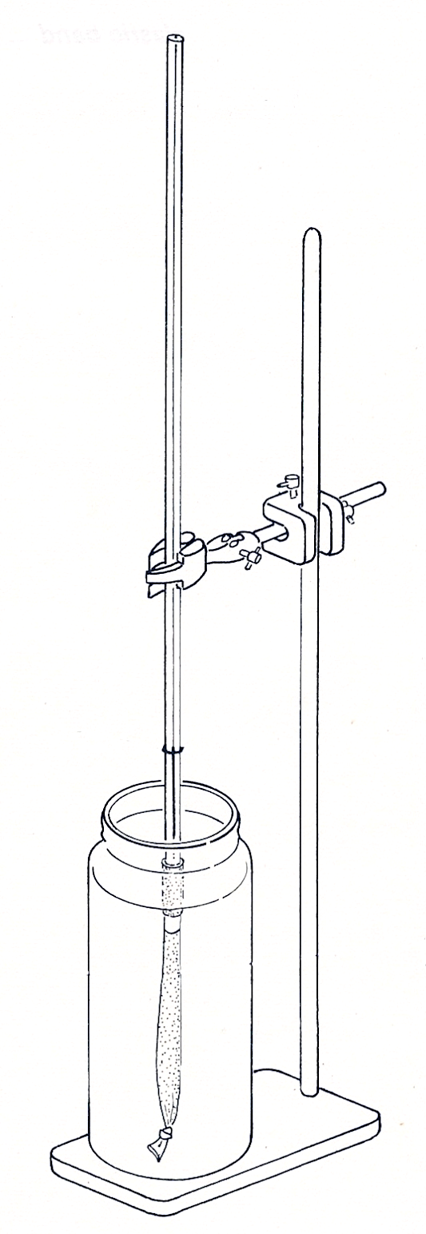
Fig.1
Fig 2
capillary tube
marker at
first level
cellophane tube
water
Fig 3

