FRENCH BEANS
Day | Action
0 | Soak
1 | Plant
2 |  | Radicles emerging 1-10 mm
3 |  | Radicles10-30 mm
4 |  | Radicles 30-40 mm  Hypocotyls 5-10 mm
5 |  | Radicles 40-60 mm  Hypocotyls 15-20 mm; ‘arching’
6 |  | Radicles 60-100 mm  Hypocotyls 20-30 mm
7 |  | Radicles 70-120 mm  Hypocotyls 25-35 mm
9 | Move seedlings to get cotyledons  near top edge of blotting paper | Radicles 100-140 mm  Hypocotyls 40-50 mm
12 | Select for experiment 17 | Hypocotyls mostly straight 50-70 mm  Epicotyls 5-10 mm
13---21 | Still suitable for experiment 17 | Hypocotyls up to 90 mm  Epicotyls from 15-50 mm
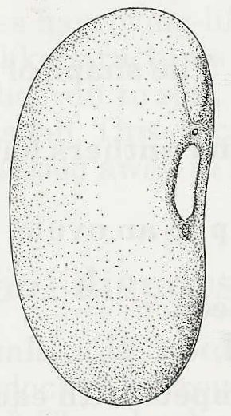
FRENCH BEAN
For conveniently shaped seedlings
plant this way up
radicle
hilum

