Brain 

The human brain is the site of the major coordination in the nervous system. It contains around 10¹⁰ neurones, each making thousands of connections to others, so the number of pathways through the brain is vast. Different regions of the brain can be identified by their appearance, and it turns out that each region has a different role.

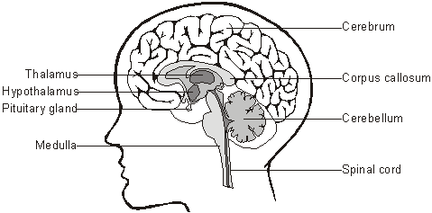

- The medulla controls heart rate, breathing, peristalsis, and reflexes such as swallowing, coughing, sneezing and vomiting.
- The Hypothalamus controls temperature homeostasis, water homeostasis, and controls the release of hormones by the pituitary gland.
- The pituitary gland secretes a range of hormones including LH, FSH, ADH, and growth hormone.
- The Thalamus is a relay station, integrating sensory input and channelling it to the sensory areas of the cerebrum.
- The cerebellum coordinates muscle movement and so controls balance, posture and locomotion (walking, running and jumping).
- The Pineal gland secretes melatonin, the hormone that regulates the biological clock.

These regions of the brain are all involved in involuntary functions, and are connected to the autonomic nervous system. A large part of the brain’s processing concerns these routine processes that keep the body working. By contrast, the upper half of the brain, the cerebrum, is responsible for all voluntary activities, and is connected to the somatic nervous system. The cerebrum is divided down the middle by a deep cleft into two cerebral hemispheres. The two halves are quite separate except for the corpus callosum, a bundle of 200 million neurones which run between the two halves. The inside contains fluid and only the outer few mm of the cerebral hemispheres contains neurones, and this is called the cerebral cortex (or just cortex). The cortex is highly folded and so has a large surface area. The cortex is the most complicated, fascinating and least-understood part of the brain.

The Cerebral Cortex

Various techniques have been used to investigate the functions of different parts of the brain. Patients with injuries to specific parts of the brain (such as stroke victims) can be studied to see which functions are altered. The brain itself has no pain receptors, so during an operation on the brain, it can be studied while the patient is alert. Different parts of the brain can be stimulated electrically to see which muscles in the body respond, or conversely different parts of the body can be stimulated to see which regions of the brain show electrical activity. More recently, the non-invasive technique of magnetic resonance imaging (MRI) has been used to study brain activity of a subject without an operation.
Studies like these have shown that the various functions of the cortex are localised into discrete areas. These areas can be split into three groups:
- Sensory areas, which receive and process sensory input from the sensory organs. There are different sensory areas for each sense organ (visual, auditory, smell, skin, etc.). The sensory neurones are first channelled through the thalamus, and they may also send impulses to other regions of the brain for autonomic processing (such as the iris response).
- Motor areas, which organise and send motor output to skeletal muscles. The motor neurones originate in these areas but are usually processed by the cerebellum before going to the muscles. So the cortex may decide to walk up stairs, but the cerebellum will organise exactly which muscle cells to contract and which to relax.
- Association areas, which are involved in higher processing.
Some of these areas are shown on this map of the surface of the cerebral cortex.

