1. The diagram below shows the structure of a liver cell as seen using an electron microscope.
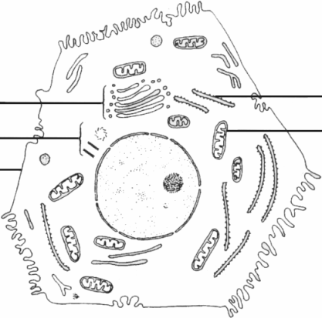
(a) Name the parts labelled A, B, C and D.
A ……………………………………………….………………………….……..
B ………………………………………………………………………………….
C ………………………………………………………………………………….
D ………………………………………………………………………………….
(4)
(b) The magnification of the diagram is × 12 000. Calculate the actual length of the mitochondrion labelled M, giving your answer in μm. Show your working.
Length ……………………..…………….…
(2)
(Total 6 marks)

2. The diagram below shows the structure of a lipid molecule.

(a) Name the parts labelled A and B.
A ……………………………………………….………………………….……..
B ………………………………………………………………………………….
(2)
(b) Name this type of lipid
……………………………………………………………………………….…..
(1)
(c) Name the chemical reaction used to form the bonds between A and B.
……………………………………………………………………………….…..
(1)
(d) State ONE function of this type of lipid in living organisms.
……………………………………………………………………………….…..
(1)
(e) State ONE feature of the molecules of this type of lipid that makes them suitable for the function you have given.
……………………………………………………………………………….…..
(1)
(Total 6 marks)

3. The statements in the table below refer to three polysaccharide molecules.
If the statement is correct place a tick () in the appropriate box and if the statement is incorrect place a cross ( X ) in the appropriate box.
Statement | Starch | Glycogen | Cellulose
Polymer of α–glucose
Glycosidic bonds present
Unbranched chains only
Energy store in animal cells
(Total 4 marks)

4. Explain what is meant by the following terms.
(a) Osmosis
……………………………………………………………………………….…..
……………………………………………………………………………….…..
……………………………………………………………………………….…..
……………………………………………………………………………….…..
……………………………………………………………………………….…..
(3)
(b) Facilitated diffusion
……………………………………………………………………………….…..
……………………………………………………………………………….…..
……………………………………………………………………………….…..
……………………………………………………………………………….…..
……………………………………………………………………………….…..
(3)
(Total 6 marks)

5. The diagram below shows the structure of a bacterial cell as seen using an electron microscope.

(a) Name the parts labelled A, C and D.
A ………………………………………………………………………….……..
B ……………………………………………………………………….....……..
C …………………………………………………..…………………..….……..
(3)
(b) Describe the roles of the parts labelled B, C and E.
B ……………………………………….………………………………………..
…………………………………………………………………………………..
C ………………………………………………………………………………..
…………………………………………………………………………………..
E ……..…………………………………………………………………………
…………………………………………………………………………………..
(3)
(Total 6 marks)

6. The photomicrograph below shows some cells.
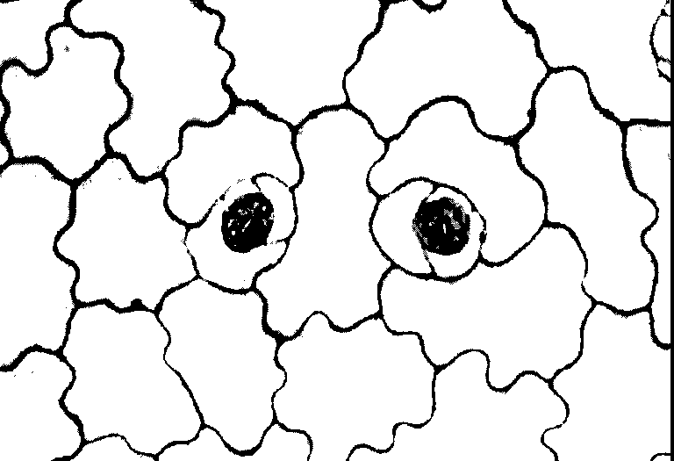

(a) Name the tissue shown in the photomicrograph and describe its function.
……………………………………………………………………………….…..
……………………………………………………………………………….…..
……………………………………………………………………………….…..
……………………………………………………………………………….…..
……………………………………………………………………………….…..
(3)
(b) In the space below make an accurate drawing, enlarged × 1.5, of the stomata and surrounding cells. Do not label your drawing.

(5)
(Total 8 marks)

7. An experiment was carried out to determine what happens to amino acids after they are absorbed by animal cells. The cells were incubated for 5 minutes in a medium containing radioactively labelled amino acids. The radioactive amino acids were then washed off and the cells were incubated in a medium containing only non-radioactive amino acids.
Samples of the cells were taken at 5, 10 and 45 minutes after the start of the experiment and the sites of radioactivity in the cells were determined.
The results are given in the table below. The figures show radioactivity in certain cell organelles expressed as a percentage of the total radioactivity within the cells.

(a) Name ONE type of molecule synthesised from amino acids in cells.
……………………………………………………………………………….…..
(1)
(b) Explain why the radioactivity is associated mainly with the rough endoplasmic reticulum after the first 5 minutes of the experiment.
……………………………………………………………………………….…..
……………………………………………………………………………….…..
……………………………………………………………………………….…..
……………………………………………………………………………….…..
(2)
(c) Explain the changes in the pattern of radioactivity in the cell during the remaining 40 minutes of the experiment.
……………………………………………………………………………….…..
……………………………………………………………………………….…..
……………………………………………………………………………….…..
……………………………………………………………………………….…..
……………………………………………………………………………….…..
(3)
(d) Suggest why the figures in the tables total less than 100%.
……………………………………………………………………………….…..
……………………………………………………………………………….…..
……………………………………………………………………………….…..
……………………………………………………………………………….…..
(2)

(e) If the experiment is continued for a further period of time, most of the radioactivity will be found outside the cell.
Name and describe the process which brings about this result.
……………………………………………………………………………….…..
……………………………………………………………………………….…..
……………………………………………………………………………….…..
……………………………………………………………………………….…..
……………………………………………………………………………….…..
(3)
(Total 11 marks)

8. Catalase is an enzyme that breaks down hydrogen peroxide into oxygen and water. The activity of catalase can be measured by soaking small discs of filter paper in a solution containing the enzyme. The discs are immediately submerged in a dilute solution of hydrogen peroxide. The filter paper discs sink at first, but float to the surface as oxygen bubbles are produced. The reciprocal of the time taken for the discs to rise to the surface indicates the rate of reaction.
An experiment was carried out to investigate the effect of substrate concentration on the activity of catalase. A filter paper disc was soaked in a solution containing catalase, and then submerged in a buffer solution containing hydrogen peroxide. The time taken for the disc to rise to the surface was recorded. This experiment was repeated using a range of concentrations of hydrogen peroxide.
The results are shown in the graph below.
(a) State why a buffer solution was used in this experiment.
……………………………………………………………………………….…..
……………………………………………………………………………….…..
(1)

(b) Describe the relationship between the rate of reaction and the concentration of hydrogen peroxide as shown by the graph.
……………………………………………………………………………….…..
……………………………………………………………………………….…..
……………………………………………………………………………….…..
……………………………………………………………………………….…..
……………………………………………………………………………….…..
……………………………………………………………………………….…..
(3)
(c) Explain this relationship between substrate concentration and the rate of reaction.
……………………………………………………………………………….…..
……………………………………………………………………………….…..
……………………………………………………………………………….…..
……………………………………………………………………………….…..
……………………………………………………………………………….…..
(3)
(d) Describe how a solution containing 160 mmol of hydrogen peroxide per dm³ would be diluted to prepare a solution containing 80 mmol of hydrogen peroxide per dm³.
……………………………………………………………………………….…..
……………………………………………………………………………….…..
……………………………………………………………………………….…..
……………………………………………………………………………….…..
(2)

(e) Describe how this experiment could be modified to investigate the effect of temperature on the activity of catalase.
……………………………………………………………………………….…..
……………………………………………………………………………….…..
……………………………………………………………………………….…..
……………………………………………………………………………….…..
……………………………………………………………………………….…..
……………………………………………………………………………….…..
……………………………………………………………………………….…..
(4)
(Total 13 marks)

9. Give an account of the process of mitosis.
...............................................................................................................................................
...............................................................................................................................................
...............................................................................................................................................
...............................................................................................................................................
...............................................................................................................................................
...............................................................................................................................................
(Allow three lined pages)
(10)

