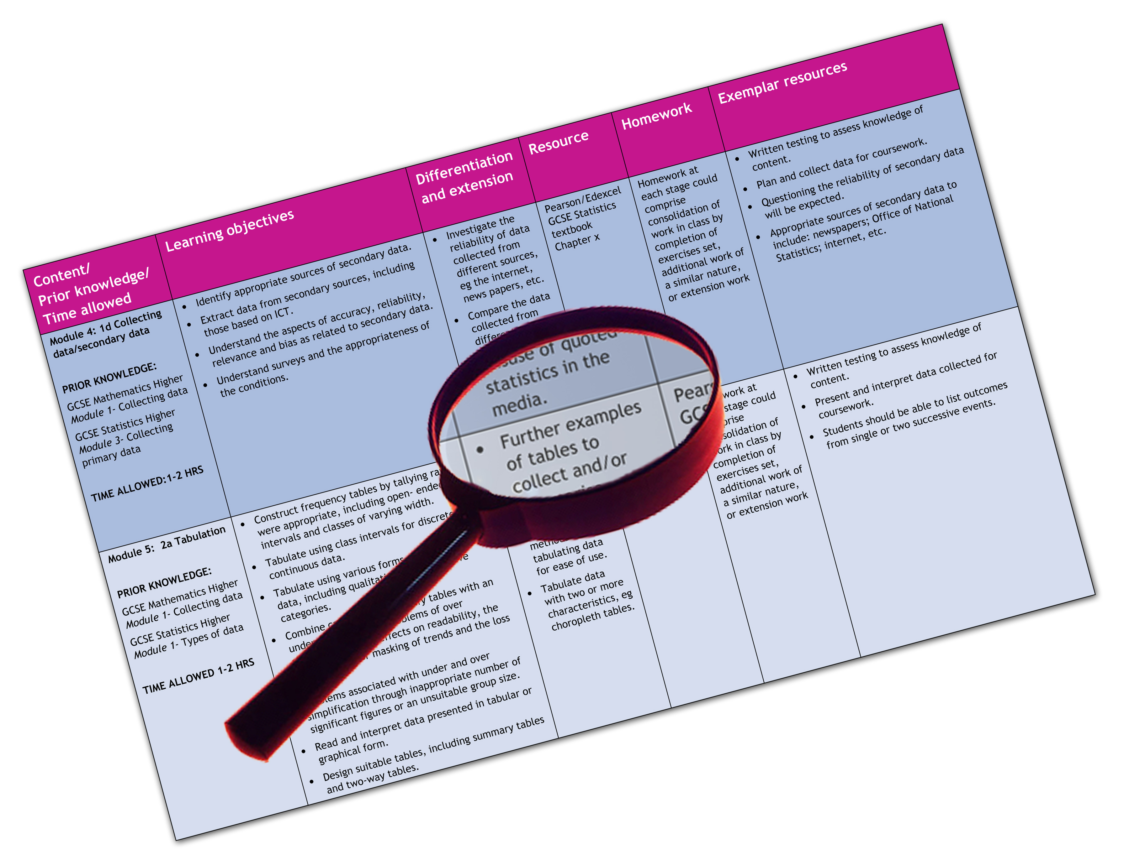


Edexcel GCE Art & Design – all endorsements
We are happy to provide this scheme of work for you to amend and adapt to suit your teaching purposes.

We hope you find this useful.
Editable scheme of work

Detailed help on resources

Week by week content coverage

Exemplar activities

Learning outcome

Units 3 and 4

A2 Art and Design
Edexcel scheme of work for GCE Art and Design
Introduction
This scheme of work covers the knowledge and skills required for coverage of the units at A2. The themes and activities chosen are exemplars and are for guidance only. Centres are free to choose or negotiate with their students, their own projects, assignments and activities for the coursework units at AS and A2.

A2 Week | Content coverage/  key questions | Learning outcomes | Exemplar activities | Exemplar materials and resources
1 | A2 Unit 3 Practical work and Personal study  Reminders of the essential elements required for Unit 3: Practical work and Personal study  The assessment objectives in relation to their chosen thematic proposal | - To know the essential elements required for A2 Unit 3: Practical work and Personal study  - To know how to write a proposal and to modify/ extend their initial intention  - To understand the assessment objectives in relation to their chosen thematic proposal | - Lecture and slide presentation: students listen and take notes on reminders of main points from example past student work for Unit 3  - Students work in groups to explore their planned proposals for Unit 3 and outline where and how they intend to cover the assessment objectives. | - The Edexcel GCE specification for Art and Design  - The A2 Assessment Grid/Guide  - Past student exemplars for Unit 3  - Hand-out frameworks for note-taking  Specialist work-spaces: e.g. studios, workshops, computer, video and film  Materials equipment and tools: e.g. for 2D, 3D, 4D and associated materials, equipment and tools across fine art specialist areas  Access to learning centre: e.g. for books, periodicals, journals, videos, CD Roms, the Internet  Visits to galleries, exhibitions, workshops and studios  - For books, journals, websites and gallery visits you might refer to the AS scheme of work, although it is expected at A2 that students will research their own specific material suited to their chosen focus for Unit 3.  However the following may be of use at this level:  - The Good Study Guide 0-7492-0044-8  - The Student Skills Guide 978-0-566-08430-0  - Study Skills 1-869866-10-X  - Learning Skills 0-00-322345-0  - Effective Study Skills 978-1-4058-4073-6  - Art-Based Research 9781853026218  - Art & Design student handbook 9781857 496376  - Art & Design the essential guide 9780340674055
2 | Review of the students’ summer vacation assignment – to research and explore ideas for their Unit 3 practical proposals | - To be able to discuss, review and evaluate own and others summer vacation assignment for A2 Unit 3: Practical work and Personal study  - To understand the language of the assessment criteria and to be able to use it in evaluating own and others’ level of achievement | - Students work in groups to present their summer vacation assignments  - Listen and contribute to evaluative activity  - Make notes on main points
3, 4 | Preliminary practical activities, developing ideas and reviewing progress | - To understand the requirements of Unit 3  - To be able to develop initial ideas from summer holiday research project  - To be able to experiment with different fine art ideas and compositions  - Understand how to research and evaluate relevant primary and contextual references  - To understand the process of reviewing ideas  - To be able to draft a proposal for their Practical work and Personal study | - Creating thumbnail sketches  - Recording from sources  - Experimenting with different approaches to composition  - Exploring relevant contextual references for information and inspiration  - Group review of initial studies  - Negotiating and writing a proposal or statement of intention for their Practical work and Personal study  Homework studies:  - Refining their proposal  - Developing a range of ideas in thumbnail sketches  - Annotating sketches to demonstrate critical understanding
5, 6, | Experimenting with materials, processes and techniques  Contextualising their ideas  Reviewing progress | - To know how to use a range of fine art media, tools and techniques appropriate to intention  - To be able to develop a series of experimental studies based on their initial ideas  - To be able to experiment with different fine art materials and processes appropriate to intention  - To understand the process of reviewing and refining experimental work | - Selecting an idea from thumbnail studies and homework extension activities  - Developing the composition in a series of studies using fine art media and processes to push their understanding of the qualities of their starting point  - Reviewing work completed thus far  - Beginning working on a range of ideas related to intention  - Referring to relevant contextual sources when appropriate  - Using 2D/3D fine art materials and techniques for further experimentation using different scale working  - Developing thumbnail studies when encountering problems  - Reviewing progress: in groups, students to discuss their ongoing work and contextual influences in informal presentations to the group
7, 8, 9, | final idea(s)  Develop final work  Contextualise the work  Refine use of media and techniques | - To know how to select and make decisions on final ideas  - To be able to develop a series of experimental studies based on their final ideas  - To be able to refine and extend skills in using different fine art materials and processes appropriate to intention  - To understand how to use others’ work to inform and inspire their ongoing ideas | - Selecting their final ideas, reviewing, refining and modifying their composition  - Contextualising their ideas – in-depth analytical study of selected, artists’ images relevant to intentions  - Tracking their progress – e.g. through annotated digital images of the work in progress and homework review of progress – e.g. through annotated thumbnail sketches and ongoing evaluative comment  - Ongoing analytical review of own work
10, 11 | Complete practical work | - To be able to complete final practical work  - To be able to complete supporting studies  - To understand where the assessment objectives have been fully met  - To review and evaluate the work on an ongoing basis | - Developing final ideas  - Completing all supporting studies  - Reviewing and refining work against the assessment objectives  - Completing final work
12, 13 | The Personal study | - To be able to select and propose a contextual enquiry relevant to their on-going Practical work  - To know how to structure a dissertation  - To understand the process of exploring an academic enquiry | - Selecting key contextual influences from their ongoing practical work  - Proposing an enquiry based on selected artists’ images  - Planning and structuring their dissertation  - Developing their research into their enquiry
14, 15 | The dissertation  Potential formats  Illustrated study | - To be able to construct a thesis  - To understand how to analyse and evaluate selected images  - To be able to draft an introduction and develop a thesis  - To know how to use images to illustrate essential points | - Group discussions set up for students to share and generate potential ideas based on their proposed enquiry  - Slide shows to demonstrate how to use artists’ images to illustrate a thesis  - Looking at exemplars of past student dissertations  - Working individually through tutorial sessions to develop dissertations
16, 17 | Final work on dissertation | - To be able to complete their Personal study  - To be able to select appropriate format for their dissertation  - To be able to present their dissertation in an appropriate format | - Working individually to complete their dissertations  - Tutorial sessions to evaluate and develop their studies  - Selecting on appropriate format for presentation
18, 19 | Final work on Practical and personal study  Presentation of Coursework Unit 3: the Practical work and Personal study | - To be able to construct a presentation of the two elements of the unit  - To be able to make a critical presentation of Unit 3 to the group | - Presenting their work in groups  - Contributing to debate  - Making notes of group critical review
Unit 4  20 | Unit 4 Externally Set Assignment  Introduction to Unit 4  Launch of the Externally Set Assignment  Focus will be on the theme set by Edexcel and the staring points given in the examination paper | - To be able to take part in discussions following the presentation of the theme  - To be able to plan ideas  - To be able to produce annotated ideas worksheets | - Participating in a stimulating presentation of imagery relevant to the given theme e.g. places, objects, contextual images; paintings, drawings, prints, sculptures, photography  - Selecting possible starting points from the examination paper as a focus for their ideas  - Group discussion followed by initial planning and chart of potential ideas based on selected starting points to the given theme
21, 22, 23, 24 | Unit 4  Selected starting points of the given theme  Ideas generation  Plans for the preparatory period  Sources relevant to the theme | - To know how to research relevant contextual references  - To be able to record from primary and contextual sources  - To be able to develop initial studies  - To be able to propose main ideas | - Group discussions to share and generate potential ideas based on the given starting points to the set theme with opportunity to view the initial slide show again to stimulate ideas  - Working from a studio set up of appropriate objects, making studies using drawing media and techniques  - Generating a series of initial thumbnail ideas trying out selected starting points  - Working in groups to analyse and evaluate selected artists ideas and use of media  - Deciding on ideas for developing final work
25, 26 | Unit 4  Proposal or statement of intent  Final personal practical work for the twelve (12) hour timed piece  Decision-making, ideas, media, materials for final work.  Full coverage of the assessment objectives  Knowledge, skills and understanding learned in Unit 3 | - To be able to write a proposal or statement of intention  - To be able to produce supporting studies  - To be able to make an extended contextual analysis  - To be able to critically review their progress | - Selecting their idea for the twelve (12) hour timed piece from their thumbnail studies and homework extension activities  - Developing their idea in a series of studies to push their understanding of the qualities of their starting point  - Reviewing work completed thus far  - Deciding on materials and media for the final piece and prepare the ground – for example: board, canvas, paper, card etc  - Reviewing progress; discussing their ongoing preparatory work together with their major contextual influences in informal presentations to the group
27,28, 29 | Preparation for final twelve (12) hour timed piece | - To understand the constraints of a twelve hour study  - To know how to plan and organise their time for the timed piece  - To be able to create a series of rough studies/ maquettes/ design worksheets in preparation for the timed piece. | - Developing and refining final idea  - Producing a series of rough studies  - Working out the time needed for each major element in their proposed final work
30, 31, | Final twelve (12) hour timed piece | - To be able to complete their idea within the twelve-hour deadline | - Completing the twelve-hour final piece
32, 33 | Review of A2 Coursework Unit 3 prior to assessment | - To understand where last minute improvements might be made  - To be able to complete/modify or add to their Unit 3 where necessary | - Going through their Unit 3 work together with supporting studies, individually through tutorials  - Modifying, refining and developing their work for Unit 3 where appropriate
34, 35 | Exhibition of the work for assessment | - To understand the most appropriate way to exhibit their work  - To be able to select, mount and present their work either in folders or in exhibition format | - Researching exhibiting and presenting  - Selecting, mounting and presenting their A2 work and supporting studies

