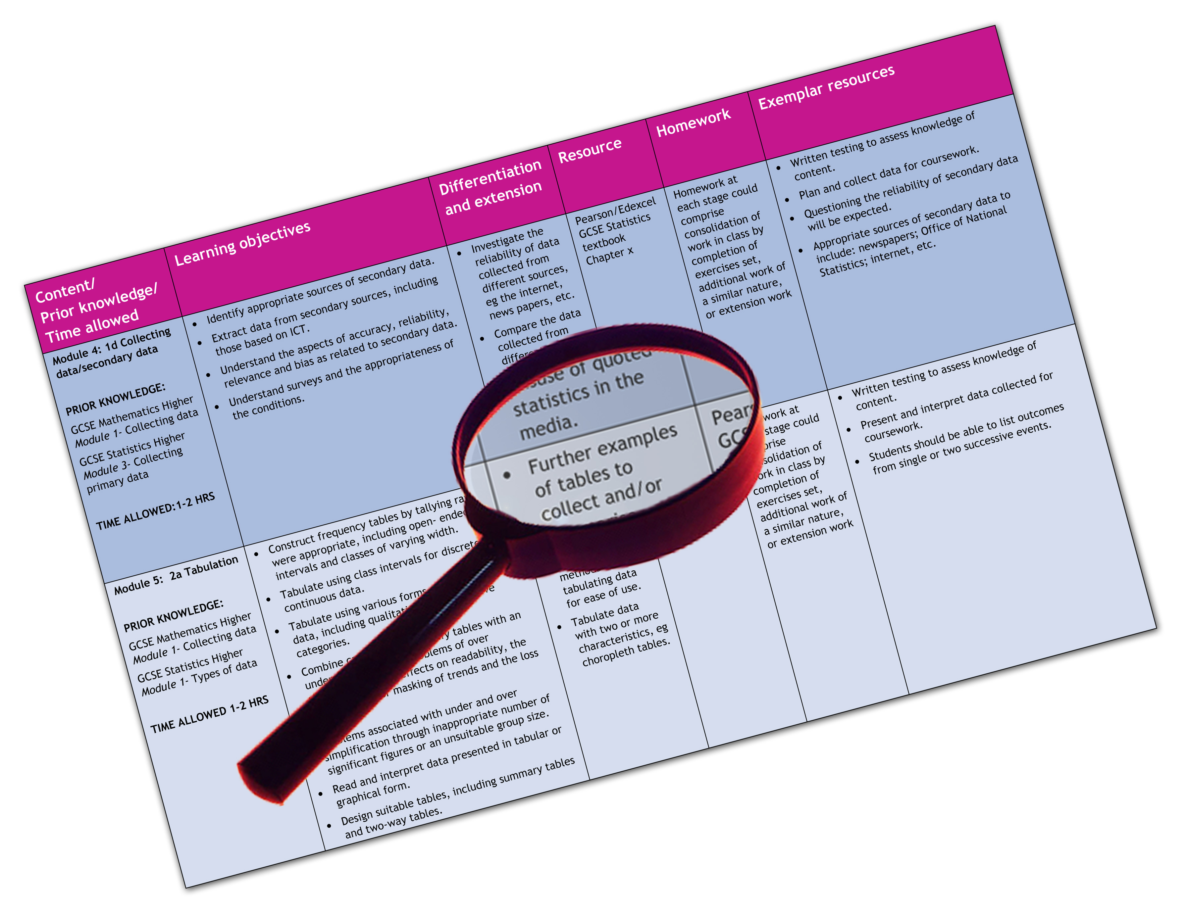


Edexcel GCE Art & Design – all endorsements
We are happy to provide this scheme of work for you to amend and adapt to suit your teaching purposes.

We hope you find this useful.
Editable scheme of work

Detailed help on resources

Week by week content coverage

Exemplar activities

Learning outcome

Unit 1 and 2

AS Art and Design
Edexcel scheme of work for GCE Art and Design
Introduction
This scheme of work covers the knowledge and skills required for coverage of the units at AS. The themes and activities chosen are exemplars and are for guidance only. Centres are free to choose or negotiate with their students, their own projects, assignments and activities for the coursework units at AS and A2.

AS Week | Content coverage/  key questions | Learning outcomes | Exemplar activities | Exemplar materials and resources
1, 2 | Induction period  Introduction to the specification  The essential elements required for Unit 1  The assessment objectives  The key focus for teaching and learning will depend on the centre-selected endorsement  In this example it is Fine Art  Introduction to the theme for Unit 1: Viewpoints | - Understand the requirements of the units at AS  - Know the requirements for Coursework Unit 1  - Understand the main elements of the theme  - Know the formal elements of mark-making  - Be able to find and select visually stimulating forms and shapes from the environment  - Be able to select, experiment with and create appropriate mark-making tools  - Understand the use of a sketchbook for homework – extending studio practical studies | - Listening to outline of the AS course; highlighting main areas for discussion; questions and answers  - Introducing the theme: Viewpoints; slide show of images: objects, details of man-made and natural form; interior and exterior viewpoints; appropriate contextual imagery  - Creating mark-making tools from found materials in the studio  - Experimenting with the formal elements of line, tone, shape/form, surface and pattern in abstract mark-making  - Discussion and review  Homework activities:  - To explore the environment for exciting found man-made and natural objects to form a studio set-up  - To make a series of sketchbook studies taken from viewpoints of their found objects | - Hand-out frameworks for note-taking  - The Edexcel Specification for Art and Design  - The assessment Grid/Guide for AS  Specialist work-spaces: e.g. studios, workshops, computer, video and film  Materials equipment and tools: e.g. for 2D, 3D, 4D and associated materials, equipment and tools across fine art specialist areas  Access to learning centre: e.g. for books, periodicals, journals, videos, CD Roms, the Internet  Visits to galleries, exhibitions, workshops and studios  Websites:  http://www.tate.org.uk/modern/  http://www.tate.org.uk/britain/  http://www.nationalgallery.org.uk/  http://www.npg.org.uk/  http://www.galleries.co.uk/  http://www.britisharts.co.uk/galleries.htm  http://www.saatchi-gallery.co.uk/  http://en.wikipedia.org/wiki/  Books on artists, sculptors, photographers and suggested teaching sources:  Bower J - Introduction to Two-dimensional Design: Understanding Form and Function (John Wiley and Sons Inc, 1999)  De Sausmarez M – Basic Design: The Dynamics of Visual Form (Herbert, 2002)  Harthill B and Clarke R - Collagraphs and Mixed Media Printmaking Handbook (A & C Black, 2005)  Beverly Hale R— Drawing Lessons from the Great Masters (Watson-Guptill, 1989)  Arranged by Motif, Colour, Period and Design (Thames and Hudson, 1991)  Newell J and Whittington D - Monoprinting (Printmaking Handbook) (A & C Black, 2006)  Peto J – Design: Process, Progress, Practice (Design Museum, 1999)  Schmidt P – Patterns in Design, Art and Architecture (Birkhauser, 2006)  Phaidon Editors - 30,000 Years of Art: The Story of Human Creativity Across Time and Space (Phaidon Press Ltd Oct 2007)  Phaidon – The Art Book (Phaidon Press Ltd; New Ed edition April 1997)  Little S – Isms – Understanding Art (A & C Black Publishers Ltd Oct 2004)  Berger J – Ways of Seeing (Penguin Books Ltd; TV Tie in Ed edition May 1990)  Hughes R – The Shock of the New – Art and the Century of Change (Thames & Hudson Ltd; Rev Ed edition Sep 1992)  Pointon M – History of Art – A Student’s Handbook (Routledge; 4Rev Ed edition Jul 1997)  Murray l – The Penguin Dictionary of Art and Artists (Penguin Books Ltd; 7Rev Ed edition Aug 1997)  Simpson I – Drawing, Seeing and Observation (A & C Black Publishers Ltd; 3Rev Ed edition Oct 2003  Stobart J – Drawing matters (C Black Publishers Ltd Sep 2006)  Oxley N – Colour Etching (A & C Black Publishers Ltd May 2007)  Noyce R – Printmaking at The Edge (A & C Black Publishers Ltd April 2006)  Cole R – Perspective for Artists (Dover Publications Inc. 1976)  Simpson I —Encyclopaedia of Drawing Techniques (Headline, 1989)  Simpson I — Drawing, Seeing and Observation (A&C Black, 1999)  Guasch Emma and Asuncion Josep — Creative Drawing (New Holland Publishers Ltd, Jan 2009)  Plowman J – Manual of Sculpting Techniques (A & C Black 2003)
3, 4, 5 | Introduction to and development of the theme for Unit 1: Viewpoints  Focus: 2D mark-making and the formal elements in black and white and tones of grey  Introduction to 3D using ceramic material | - Be able to experiment with a wide range of mark-making tools and techniques  - Know the formal elements and be able to use them in mark-making and recording from sources  - Be able to create 2D and 3D images and structures  - Understand the use of a sketchbook for homework – extending studio practical studies  - Be able to record from primary and contextual sources | From the studio set-up of found objects of interesting forms, shapes etc, students create:  x 6 A2 mark-making sheets and  x 6 clay maquettes employing the formal elements of line, tone, form, shape, structure, surface and pattern  Exploring viewpoints of selected areas of studio set-up through finding visual equivalents to the qualities of selected objects. Eg a piece of driftwood might have qualities of: gnarled, twisted, fissured, pitted broken, cracked etc  - Using appropriate mark-making tools to explore line, tone, form, shape, structure, surface and pattern  Exploring viewpoints of relevant contextual references for the purpose of:  - Discussion and analysis of contextual references  - Reviewing progress  Homework activities  - To select specific objects for visual analysis focussing separately on each of the formal elements – excluding colour at this stage  - To make a detailed annotated visual analyses of selected contextual images focussing separately on each of the formal elements – excluding colour at this stage | Specialist work-spaces: eg studios, workshops, computer, video and film  Materials equipment and tools: eg for 2D, 3D, 4D and associated materials, equipment and tools across fine art specialist areas  Access to learning centre: eg for books, periodicals, journals, videos, CD Roms, the Internet  Visits to galleries, exhibitions, workshops and studios  Websites as suggested above  Books on artists, sculptors, photographers and suggested teaching sources listed above
6, 7 | Introduction to colour, media, materials and processes  Objective and subjective use of colour  Contextual references  Critical review | - To understand the use and application of colour  - To be able to use tools, colour media, materials and techniques  - To be able to research and use contextual references  - To be able to experiment with a wide range of colour media, mark-making tools and techniques  - To be able to critically review own progress | - Finding visual equivalents to the colour qualities of selected objects and viewpoints. Eg a piece of corroded metal might have colour qualities of: burnt, rusted, blue-blackened, harmonies and contrasts, light/dark gradations etc  - Exploring colour mixing and application techniques using different wet and dry colour media  - Exploring colour relationships - contrasts, harmonies and qualities of warmth/coolness  - Exploring colour in selected contextual references  - Exploring colour and light, colour composition and colour atmosphere  - Exploring techniques using oils and acrylics  - Critically analysing selected contextual references  - Critically reviewing progress  Homework activities:  - To make colour sketches in oil and chalk pastels of natural objects  - To make a series of sketchbook studies in oil and chalk pastels taken from viewpoints of their local interior/exterior environment. | Specialist work-spaces: eg studios, workshops, computer, video and film  Materials equipment and tools: eg for 2D, 3D, 4D and associated materials, equipment and tools across fine art specialist areas  Access to learning centre: eg for books, periodicals, journals, videos, CD Roms, the Internet  Visits to galleries, exhibitions, workshops and studios  Websites as suggested above  Books on artists, sculptors, photographers and suggested teaching sources including those previously listed:  Van Vliet Rolina — Painting Abstracts — Ideas, Projects and Techniques (Search Press Ltd, July 2008)  Sheaks Barclay — The Acrylic Book: Materials and Techniques for Today’s Artist (Watson-Guptill Education inc. May 2000)  Galton Jeremy — The Encyclopedia of Oil Painting Techniques (Search Press Ltd, Jan 2001)  Allrich Steve — Oil Painting for the Serious Beginner (Watson-Guptill Education inc. Sept 2004)
8, 9, 10 | Introduction to composition  Viewpoints:  Interior/exterior  Focus will be on using colour in different ways for different effects working from observation  Contextual sources will provide essential exemplars for each activity  Experimentation with wet and dry black and white and colour media, materials and techniques  Experimentation with 3D using ceramic materials | - To know how to use the formal elements in drawing painting and sculpture  - Be able to produce a series of black and white and colour studies from different subjects  - To understand how to create effective pictorial composition, figure and ground, space/shape relationships, depth and direction, light and shadow, surface tension, abstraction of form, assemblage and composite image creation  - To be able to use basic ceramic sculpting processes | - Framing a range of viewpoints  - Creating a series of black and white thumbnail sketches in line and tone  - Creating a series of colour studies using a range of colour harmonies and contrasts  - Experimenting with mixed media: collage, montage, paint, oil/chalk pastels etc  For 3D option:  - Creating a series of maquettes from 2D developed studies  - Experimenting with form and shape: developing 3D sculpture through ceramic processes  Homework activities:  - Developing their understanding of composition through a series of studies from selected objects and views  - Researching into appropriate artists’ compositions to inform their work, with selected visual and written analysis | Specialist work-spaces: eg studios, workshops, computer, video and film  Materials equipment and tools: eg for 2D, 3D, 4D and associated materials, equipment and tools across fine art specialist areas  Access to learning centre: eg for books, periodicals, journals, videos, CD Roms, the Internet  Visits to galleries, exhibitions, workshops and studios  Books on artists, sculptors, photographers and suggested teaching sources including those listed previously:  Lark Books — 500 Ceramic Sculptures (Lark, 2009)  Minoque Coll — Slab-Built Ceramics (The Crowood Press, May 2008)  Gooding M – Song of the Earth (Thames & Hudson Ltd Sep 2002)  Goldsworthy A – Andy Goldsworthy (Harry N. Abrams, Inc. Jan 1998)  Opie M-J – Sculpture (Eyewitness Art) (Dk Pub (T) Dec 1994)  Collins J – Sculpture Today (Phaidon Press Ltd Oct 2007)
11-15 | Proposal for final personal practical work  Contextual connections  Media, materials and techniques  Critical review  Focus will be on deciding on their composition, selecting media, materials and developing final work. | - To understand how to construct a proposal or statement of intention  - To be able to develop and modify ideas through thumbnails, rough studies, maquettes etc  - To be able to use artists’ work to inform and inspire their ongoing ideas  - To be able to select a final idea for their viewpoint composition  - To be able to select and use appropriate media and processes  - To be able to critically review their progress | - Negotiating a direction for their own work and writing a proposal or statement of intention  - Selecting an idea for a 2D composition or a 3D structure from their thumbnail studies and homework extension activities  - Developing the composition /structure in a series of studies to push their understanding of the qualities of their starting point  - In groups, reviewing work completed thus far  - Selecting a study for further development and where necessary going back to the original viewpoint for further recording  - Deciding on materials and media for the final piece to prepare the ground – for example, board, canvas, paper, card, ceramic material  - Beginning work on final piece; refer to contextual sources when appropriate; use sketchbook/rough paper or maquettes/test pieces for further experimentation; use thumbnail studies when encountering composition/ design problems  - Reviewing progress - discussing their ongoing work and contextual influences in informal presentations to the group  Homework activities:  - Developing and refining final idea  - Annotating sketches to demonstrate critical thinking and showing connections to appropriate contextual imagery. | Specialist work-spaces: eg studios, workshops, computer, video and film  Materials equipment and tools: eg for 2D, 3D, 4D and associated materials, equipment and tools across fine art specialist areas  Access to learning centre: eg for books, periodicals, journals, videos, CD Roms, the Internet  Visits to galleries, exhibitions, workshops and studios  Books on artists, sculptors, photographers and suggested teaching sources including those previously listed:  Malins Frederick — Understanding Paintings – The Elements of Composition (Prentice Hall Trade, Dec 1980)  Roberts Ian — Mastering Composition (North Light Books, Jan 2008) 978-1581809244
16-18 | Final coursework outcome  Supporting studies  Focus will be on completing final work and presenting supporting studies - sketchbooks and roughs | - To be able to complete final composition/design  - To be able to complete supporting studies  - To be able to present their final work and supporting studies to the group | - Working on their final ideas  - Reviewing, refining and modifying their compositions/designs  - Tracking their progress towards completion of their final pieces – eg through annotated digital images of the work in progress and homework review of progress – eg through annotated thumbnail sketches and ongoing evaluative comment  - Completing final composition/design  - Presenting their work to the group  Homework activities:  - Preparing a presentation of their work and supporting studies to the group.
19 | AS Unit 2 Externally et Assignment  Introduction to Unit 2  Launch of the Externally Set Assignment  Focus will be on the theme and starting points set by Edexcel | - To be able to take part in discussions following the presentation of the Externally Set Assignment theme  - To be able to plan ideas  - To be able to produce annotated ideas worksheets | - Participation in a stimulating presentation of imagery relevant to the given theme eg places, objects, contextual images; paintings, drawings, prints, sculptures, photography  - Selecting possible starting points from the examination paper as a focus for their ideas  - Group discussion followed by initial planning and chart of potential ideas based on selected starting points to the given theme  Homework activities:  - Generating a range of sketchbook thumbnail ideas from the class slide presentation and discussion | Specialist work-spaces: eg studios, workshops, computer, video and film  Materials equipment and tools: eg for 2D, 3D, 4D and associated materials, equipment and tools across fine art specialist areas  Access to learning centre: eg for books, periodicals, journals, videos, CD Roms, the Internet  Visits to galleries, exhibitions, workshops and studios  Websites as for Unit 1, including those given on the examination paper  Books on artists, sculptors, photographers and suggested teaching sources including those previously listed for Unit 1, including those given on the examination paper
20,21,22 | Unit 2  Selected starting points of the given theme  Ideas generation  Plans for the preparatory period  Sources relevant to the theme | - To know how to research relevant contextual references  - To be able to record from primary and contextual sources  - To be able to develop initial studies  - To be able to propose main ideas | - Group discussions to share and generate potential ideas based on the given starting points to the set theme  - Opportunity to view the initial slide show again to stimulate ideas  - Working from a studio set up of appropriate objects, students making studies using drawing media and techniques  - Generating/developing a series of thumbnail ideas trying out selected starting points  - Working in groups to analyse and evaluate selected artists ideas and use of media  - Deciding on ideas for developing final work
23,24,25 | Unit 2  Proposal or statement of intent  Final personal practical work for the eight (8) hour timed piece  Decision-making, ideas, media, materials for final work.  Full coverage of the assessment objectives  Knowledge, skills and understanding learned in Unit 3 | - To be able to write a proposal or statement of intention  - To be able to produce supporting studies  - To be able to make an extended contextual analysis  - To be able to critically review their progress | - Selecting their idea for the eight (8) hour timed piece from their thumbnail studies and homework extension activities  - Developing their idea in a series of studies to push their understanding of the qualities of their starting point  - Reviewing work completed thus far  - Deciding on materials and media for the final piece and prepare the ground – for example, board, canvas, paper, card, clay etc  - Reviewing progress; students discussing their ongoing preparatory work together with their major contextual influences in informal presentations to the group  Homework activities:  - Practising a mock piece to analyse the problems of completion within the eight hours.
26,27,28 | Preparation for final eight (8) hour timed piece | - To understand the constraints of an eight-hour study  - To know how to plan and organise their time for the timed piece  - To be able to create a series of rough studies in preparation for the timed piece. | - Developing and refining final idea  - Producing a series of rough studies  - Working out the time needed for each major element in the composition  Homework activities:  - Practising a mock piece to analyse the problems of completion within the eight hours.
29, 30 | Final eight (8) hour timed piece | - To be able to complete their idea within the eight-hour deadline | - Completing the eight-hour final piece
31, 32, 33 | Review of AS Coursework Unit 1 prior to final assessment | - To understand where last minute improvements might be made  - To be able to complete/modify or add to their Unit 1 where necessary | - Reviewing their Unit 1 supporting studies and final work, individually, in groups and through tutorials  - Modifying, refining and developing their work for Unit 1 where appropriate
 | Exhibition of the work for assessment | - To understand the most appropriate way to exhibit their work  - To be able to select, mount and present their work either in folders or in exhibition format | - Researching exhibiting and presenting work for Unit 1  - Selecting, mounting and presenting their AS work and supporting studies
34, 35, 36 | Review of AS Coursework Unit 1 for development of summer vacation research project  Major focus: summer vacation work leading to A2 Unit 3 | - To understand the most successful areas of their AS work  - To be able to select an area for developing a summer vacation research project  - To know the requirements for A2 Unit 3 | - Working in groups to self and peer evaluate their AS work; discussing strengths and weaknesses  - Negotiating a summer vacation project based on their strengths and current interests

